
Observer Report
Created on Thursday, 20 April 2023 4:29:22 PM
Production Information
Shotpoints Acquired Today
1111
Aborted Shots/Sweeps
1
First Shot
20/04/2023 8:03:40 AM UTC +10 hours
Last Shot
20/04/2023 4:16:32 PM UTC +10 hours
Production Time
8 hours 12 minutes
Total Acquired
1820
Planned Shots
5732
Remaining Shots
3912
Today's Acquisition Speed
135 Shotpoints/Hour
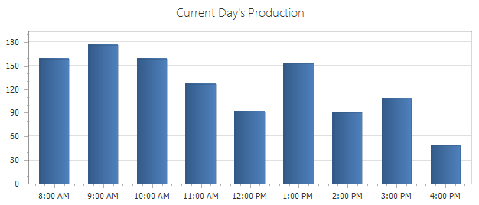
Production
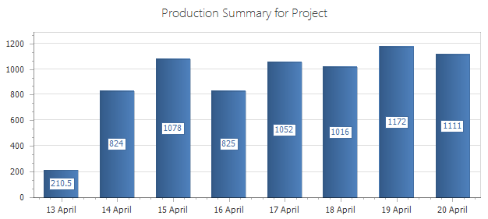
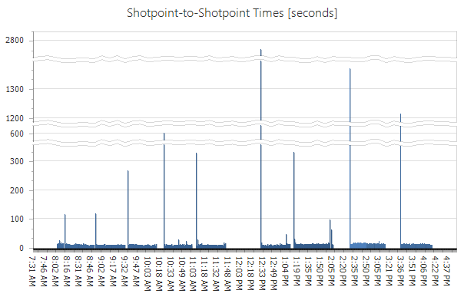
Overhead and Downtime
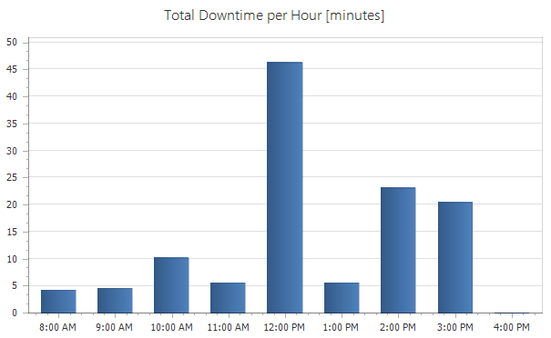
Area Map
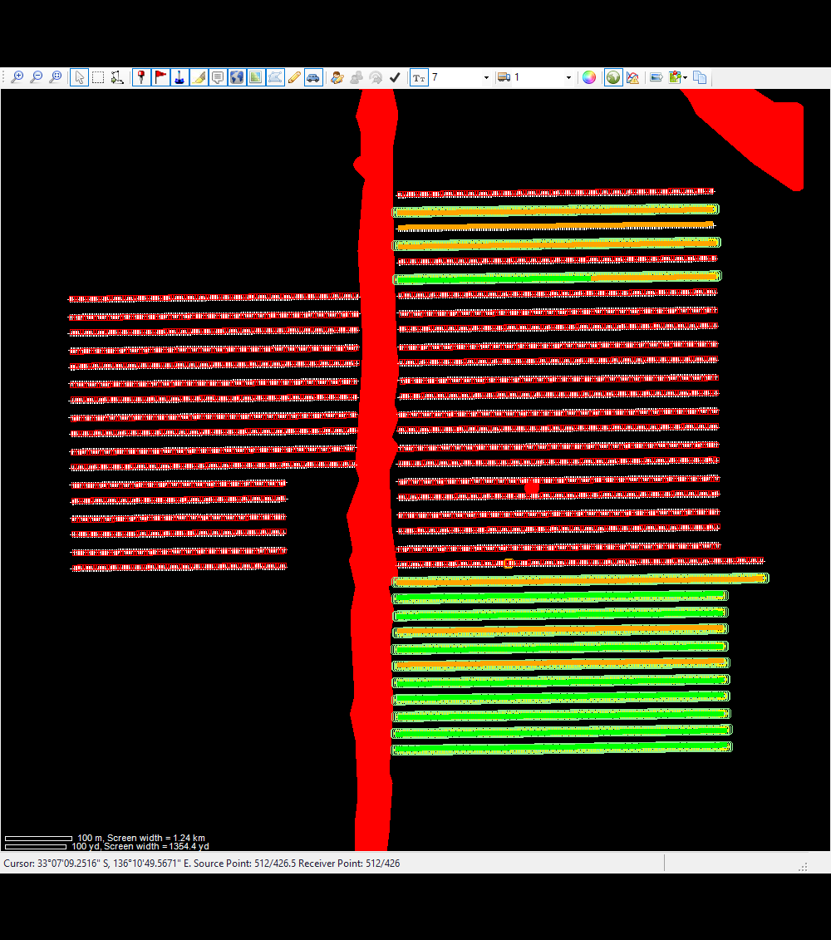
List of Source Decoders
Group
Unit
Type
Driver/Shooter
1
4
Force Three

Vibrator Error Summary
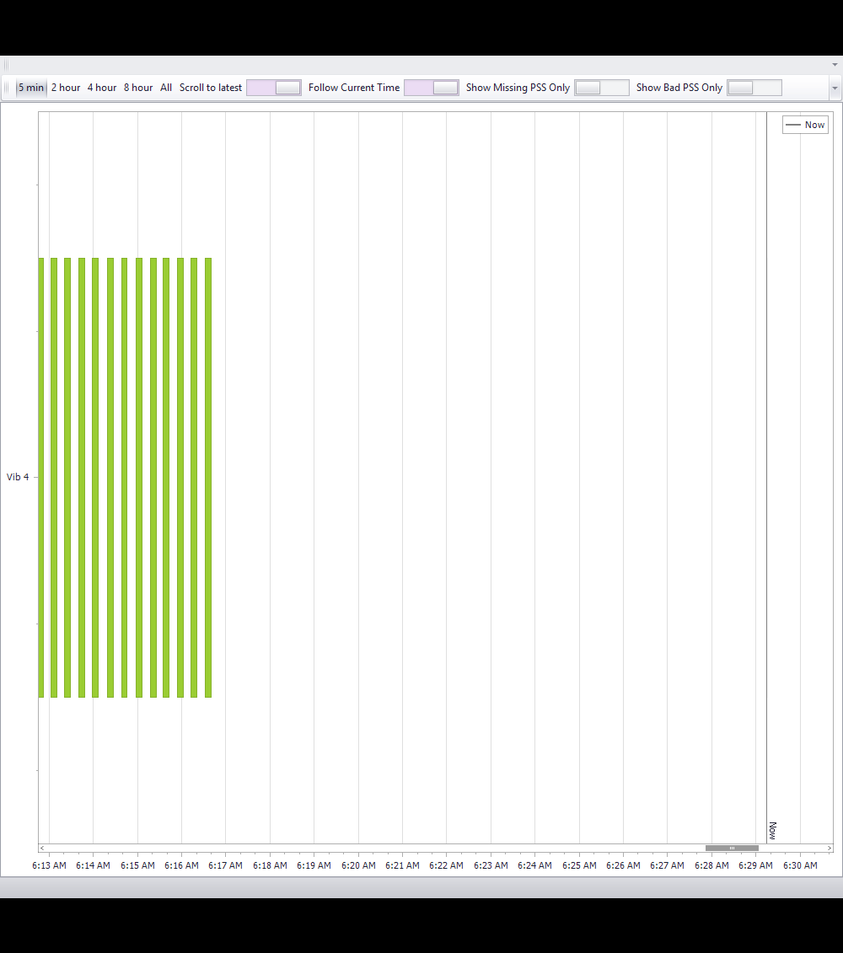
Vibrator PSS Information
PSS Geographical Representation
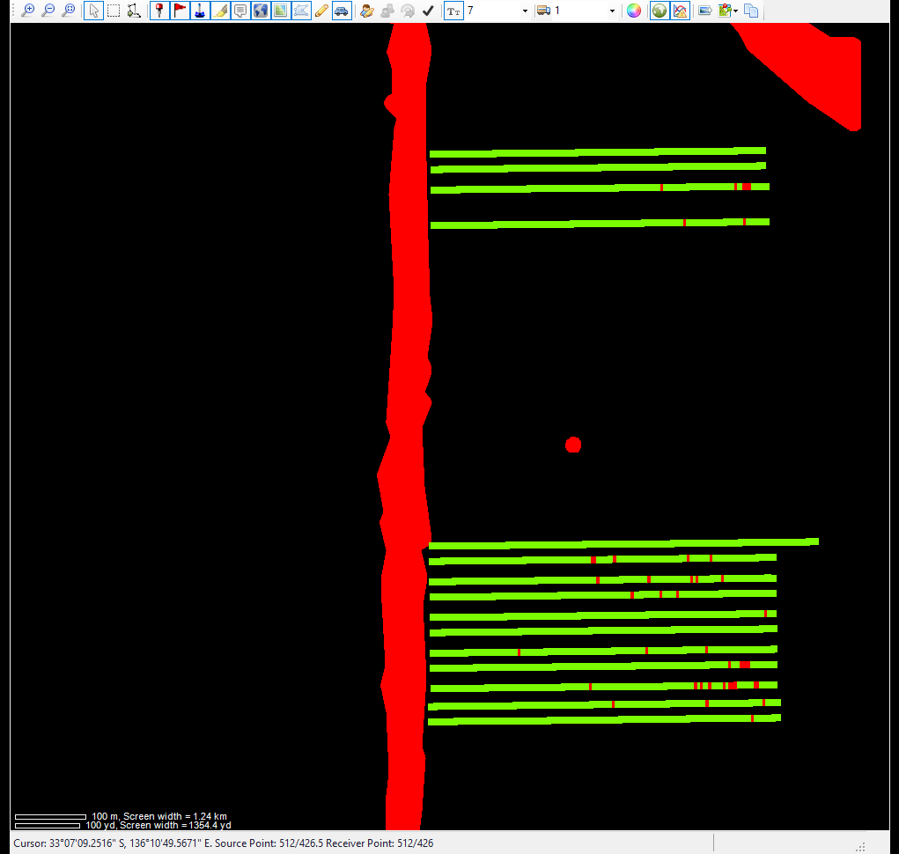
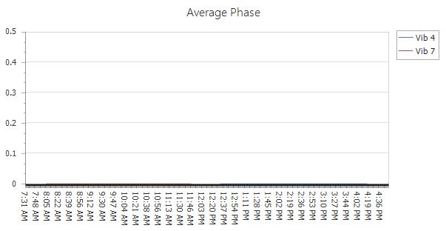
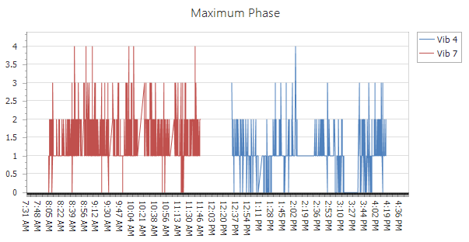
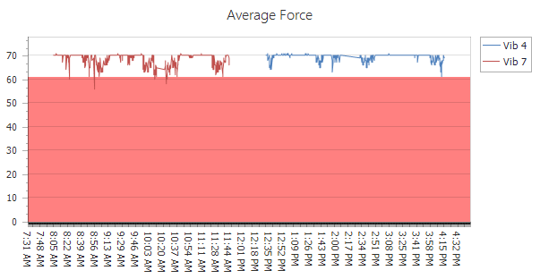
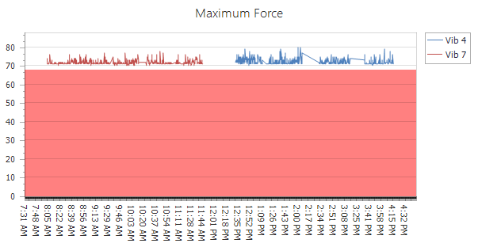
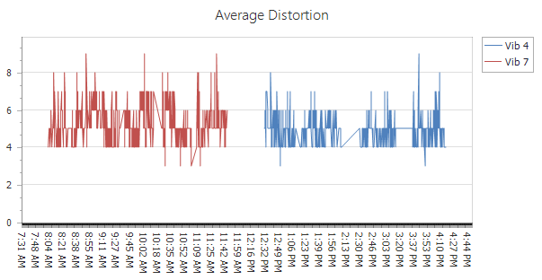
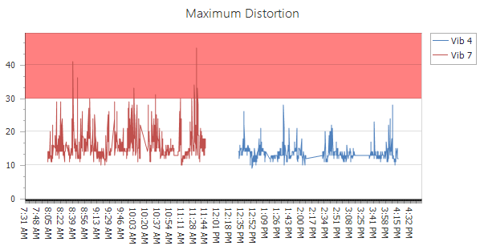
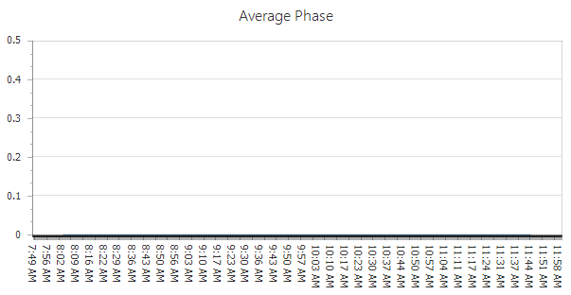
7
Vibrator
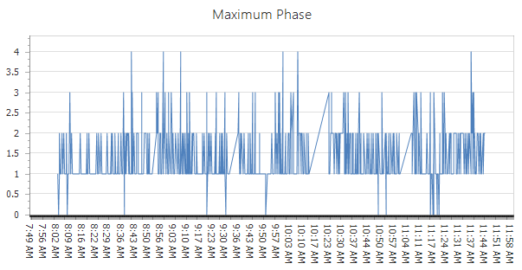
Phase Plots
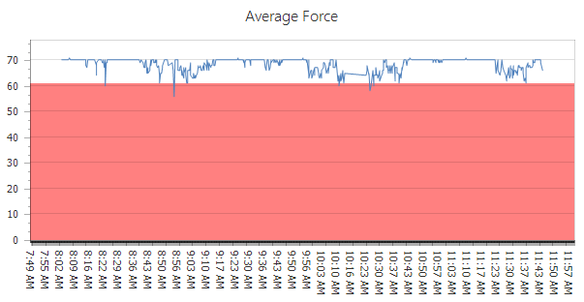
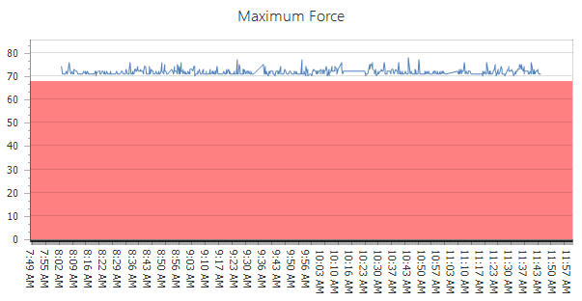
Force Plots
7
Vibrator
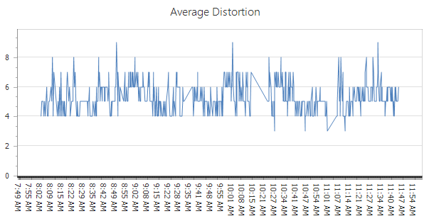
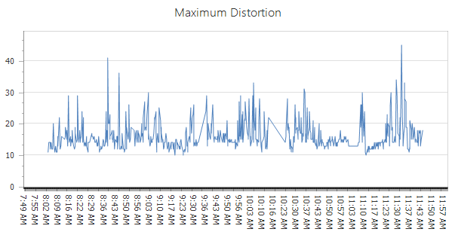
Vibrator
7
Distortion Plots
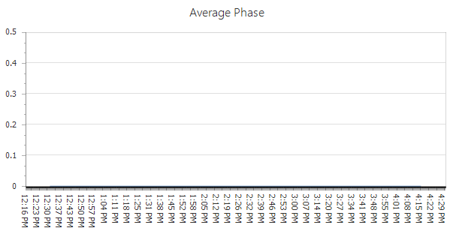
4
Vibrator
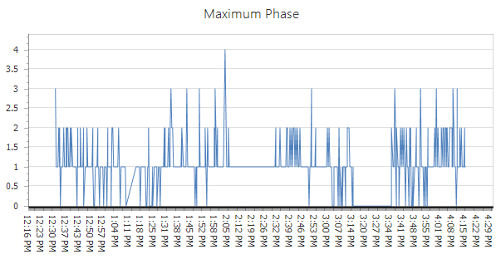
Phase Plots
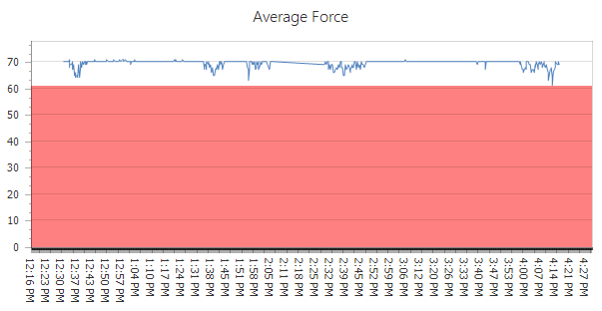
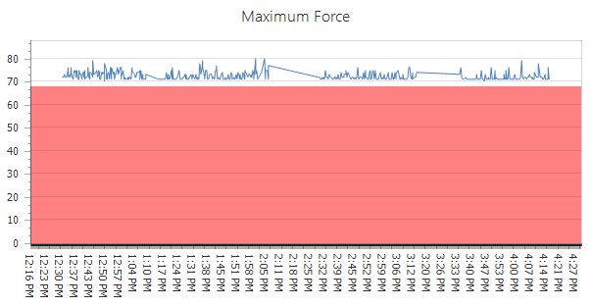
Force Plots
4
Vibrator
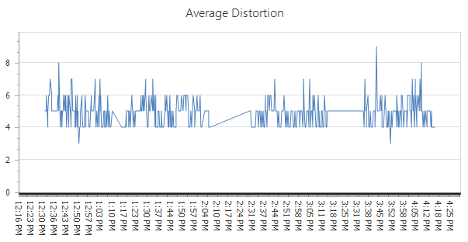
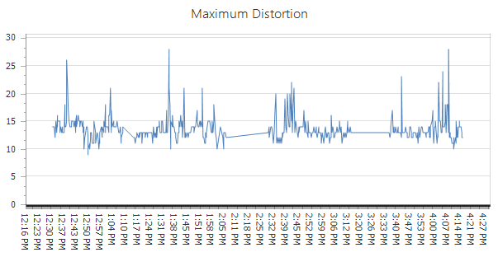
Vibrator
4
Distortion Plots

